Pumalin Park: A conservation model for preservation of biodiversity and sustainable human development.

Introduction

Ever since the birth of environmentalism in the 1960’s, people have experienced a growing awareness of how we affect the environment. But at the same time, this movement has been eclipsed by activities such as human expansion, pollution, and industrialization. All of these activities can be put into one word: Human Progress. This conflict is a modern version of David and Goliath’s battle with a little twist. David, being the good, small environmentalists trying to fling some rocks at this colossal opponent in order to make justice for the environment; Goliath, being the greedy, powerful businessmen who won’t hesitate to destroy the environment if there’s a profit to be made. In the end, unlike the biblical story, Goliath always seems to win. Human Progress always seems to trample over the environment. Well, what if I told you that my research has taught me that David and Goliath can hold hands and take long walks on the beach? What if I told you that Human Progress and the Environment are so essential to one another that they, in fact, rely on each other? In the mystical rainforests of northern Patagonia, there is a conservation model in which human progress coexists peacefully with the preservation of the environment. In this research paper I will analyze in depth the conservation model of Pumalin Park in northern Patagonia. I will describe the history of the park, how preservation and conservation coexist at Pumalin, what opposition the Pumalin administration has faced, and how different social initiatives help to further conservation efforts. As a product of my extensive field work at the Park, the following research question arose: Can human progress coexist with the conservation model of Pumalin Park? My field work indicates they indeed can coexist. Because human progress relies on the environment, it is a necessity to protect the environment as well. The Pumalin conservation model not only protects the environment, but also allows human progress to occur.

History of Pumalin Park

Pumalin Park, located in Chilean Patagonia, is the largest privately owned conservation area in the world, for the past 25 years, the administration of Pumalin Park have strived to preserve this unique ecosystem, declare conservation areas for tourism, and emphasize the importance of a sustainable human development to improve the lives of the communities that live at the Park.

Pumalin Park was not acquired in one sitting. In 1991, the American entrepreneur Douglas Rainsford Tompkins--Founder of The North Face and active conservationist-- acquired a 42,000-acre farm in Reñihue Valley in order to conserve its native temperate rainforest. On the years that followed, Doug along with a series of foundations (some of which he founded himself) proceeded to acquire more than 700,000 acres in the surrounding areas, and 98% percent of them from absentee owners. Doug had visited Chile several times since the ‘60s, and Patagonia was by far his favorite place to visit. In this trips, he devoted his time to mountain climbing and whitewater rafting among many other outdoor activities. Doug didn’t only enjoy nature but also had a deep concern about its future. His biggest concerns were fighting the global extinction crisis (the alarming rate at which species have been driven to extinction by irresponsible human progress) and the protecting the Earth’s last remaining wilderness.

After 1994, Douglas finally retired completely from the corporate world, moved to Chile and lived there full time. He devoted himself to the conservation of Pumalin Park among many other lands he owned in both Chile and Argentina that he acquired for conservation purposes. But Tompkins knew he couldn’t sustain his conservation efforts forever, after all, he was not in the corporate world anymore, and his money wasn’t going to last forever. This is why he had a dream: to build a strong network of National Parks throughout Chile and Argentina. But why National Parks? Because that is the highest legal conservation status you can obtain from any government. Also, it implies that the government will be required to invest in the park and not rely on a private owner for conservation efforts. Despite his willingness to donate his own lands to the State with the condition of having them declared National Parks, it is not an easy task to get a government to declare a National Park. This requires an immense amount of monetary investment for the creation and maintenance of a vast conservation area. As a consequence of these implications, Tompkins dream always relied on the collaboration of the State.

On December of 2015, Doug set out for his last adventure.

Doug passed away on December 8th, due to a kayaking accident in Patagonia. He may have passed, but his dream lives on. His wife, Kristen Tompkins--Ex-CEO of Patagonia Inc.-- along with every single person that works at Pumalin Park, have made sure to work untiringly towards the conservation and preservation of this unique ecosystem.

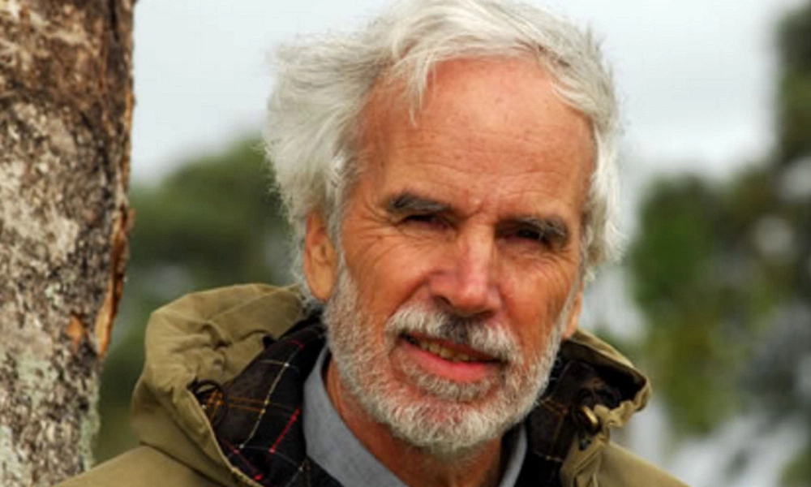
Douglas Rainsford Tompkins

Conservation vs Preservation: Is it really a debate?

My research started upon my arrival to Chaiten on April 16th, and it was in this little town where Rodrigo Villablanca, chief administrator of Pumalin South, picked me up and took me to my cabin on the South side of Pumalin Park. Once established, I began my field work.
Every day consisted of going on rides with different people who had different roles at the Park. The first couple of days were crucial to understanding the purpose of Pumalin Park. Rodrigo Villablanca and Erwin Gonzalez, both administrators of different sections of the Park, explained to me how conservation and preservation coexist in the Park. But what’s the difference between these two? A preservation area, environmentally speaking, is any legally protected area in which no human intervention is allowed, whereas a conservation area is a legally protected area in which people are allowed to practice outdoor activities such as camping and hiking. Also, natural resources can be utilized at conservation areas (logging is very common on forestal conservation areas) as long as this is done in a sustainable manner. Both preservation areas and conservation areas serve the purpose of protecting the environment, with the only difference that conservation implies human interaction and preservation does not. What’s really unique about Pumalin Park is that conservation and preservation work in tandem. Having the main Carretera Austral highway (which is actually just a dirt road) cutting through the Park, Pumalin Park could not be preserved entirely given the human interaction that the annual flow of tourists going through this highway meant. Given this problem, the administration decided to conserve the areas surrounding the Carretera Austral and set up camping sites, hiking trails, and even a few cabins to receive and educate tourists about the importance of these conservation efforts. Conserving this area surrounding the Carretera Austral benefits the preservation of the rest of the park that’s away from it, protecting wildlife while managing sustainable tourism. This ingenious solution not only allowed the Pumalin administration to preserve this ecosystem but also made the Park accessible to the general public, thus, unifying taking care of the environment with a responsible human progress. On my interview with Erwin Gonzalez, the general administrator of Pumalin West, he explained to me that it would have been catastrophic for the environment if they had actually decided to preserve the entirety of the Park, given that tourists would resort to camping illegally on the Park and actually do more damage to the environment than they would in a designated sustainable campsite. He also elucidated that given the increasing numbers of tourists that have been visiting Pumalin (In the 2015 summer season about 50,000 tourists visited the Park, whereas in the 2016 summer season the number of visitors exceeded 70,000) the Pumalin administration felt an obligation to address tourism in order to prevent unregulated camping affect other areas of Patagonia along the Carretera Austral.

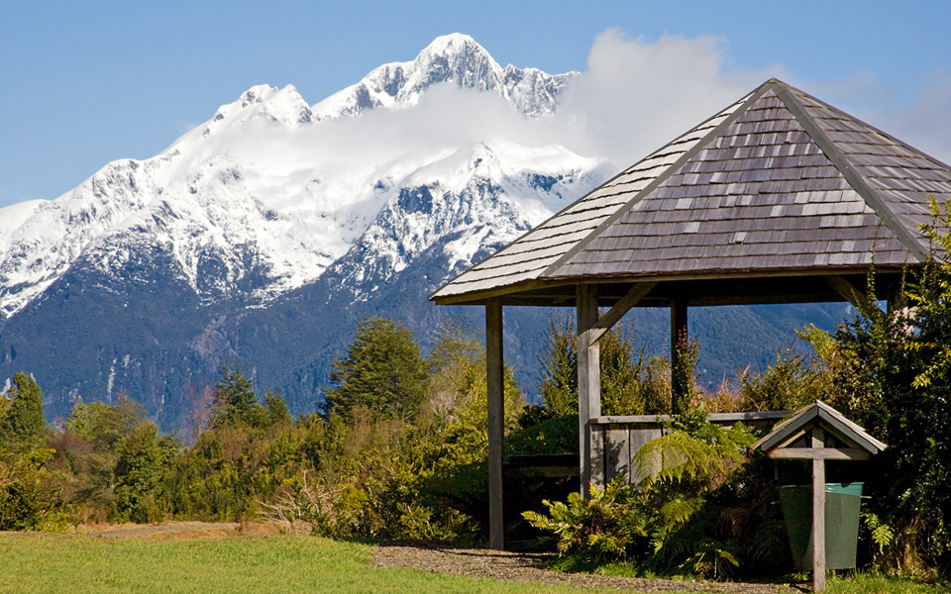
Campsite at Pumalin Park

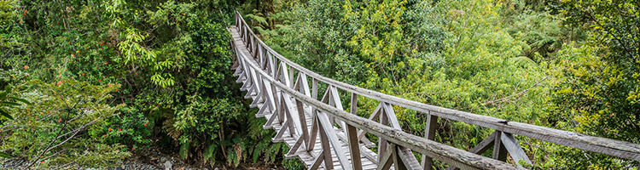
Trail at Pumalin Park
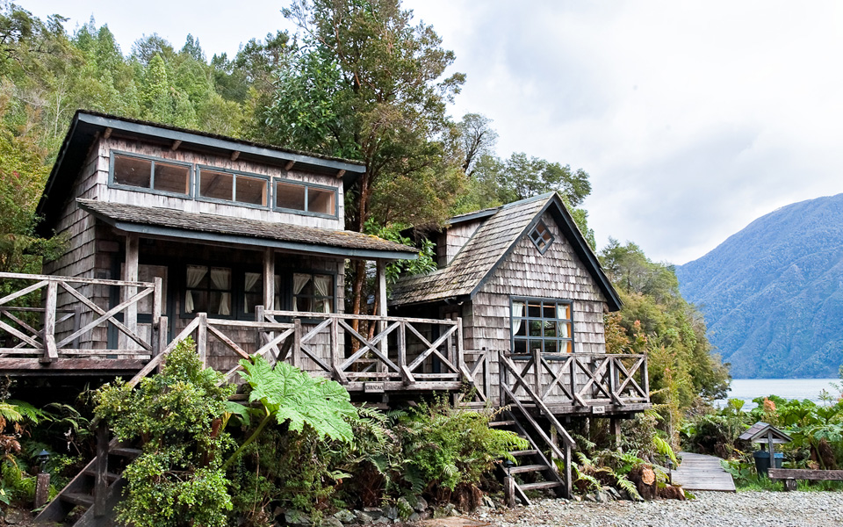
Cabins at Pumalin Park

The Opposition

My research consisted in finding as much information as I could on Pumalin Park while I was still in the US, to subsequently travel to Chile in order to engage in my field work. But there was very little information about the Park online. Despite having a difficult time searching, I was able to research some of the initiatives for the conservation of the Park. After searching for various articles about the Park, I also stumbled upon a number of articles which were against the conservation initiatives of Pumalin Park. Some local authorities were seriously concerned with the preservation initiatives, and argued that a foreigner (Tompkins) shouldn’t be allowed to obstruct government initiatives even if they infringed preservation efforts at the Park. Also, many locals were infuriated because they were no longer allowed to do activities that they had been doing for decades such as hunting, fishing, and logging. As a result, the establishment of Pumalin Park faced a considerable opposition from locals. I later found out that the opposition had decreased since the creation of Pumalin Park as a product of the incorporation of the locals into the Pumalin workforce, and clearer information about the administration’s willingness to collaborate with the government.

Congressman David Sandoval/ Tompkins outspoken opposer

Social Initiatives

Rodrigo showed me around the little village that we were in and explained to me some of the social initiatives that are in place for the community that works at Pumalin Park. One of them was the “Embellishment Project” which aimed to improve the houses and yards of a small town right outside Pumalin South called “El Amarillo”, where most of the population that work at Pumalin South live. This Project changed radically the reality of the workers of the Park. Unlike “El Amarillo”, most nearby towns who aren’t under the wing of the Pumalin administration consists of miserable settlements with houses made out of precarious tin roofs and wooden (sometimes rotten) walls. Adding to that, many people in the area rely on raising livestock and planting crops in order to feed themselves as well as their families. Sadly, most yards are poorly maintained and it makes it hard for them to raise farm animals or plant crops. The “Embellishment Project” is the solution that the Pumalin administration created to address this problem. This project works in different ways. One of the labors includes cutting tall grass, removing weeds, and restoring the eroded soil in order to be able to plant crops and raise small livestock such as chickens and sheep. It also deals with home improvements such as replacing aesthetically unappealing tin roofs with recycled, good-quality wood, and installing sustainable heating systems such as fire stoves (in which one can cook as well). This project was entirely financed by the Pumalin administration with the goal of improving people’s lives in order to create a strong local pride. As a result, a micro-sustainable economy was born.

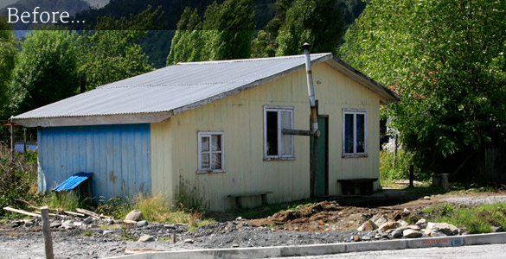
House in “El Amarillo” before “Embellishment Project”
House in “El Amarillo” after “Embellishment Project”

I personally experienced this way of living at my cabin. I relied on a fire stove to cook and heat up the entire cabin, washed my dishes with cold water only, and used electricity (which was available at the cabin) generated by a small river turbine nearby. I was amazed by how well I could live with such a small carbon footprint. At a local scale, I learned that the “Embellishment Project” was the most important project in place. At a larger scale, there is an even bigger project named the “Scenic Route”.

The “Scenic Route” project consists of a series of improvements throughout the Carretera Austral highway in order to beautify roadsides and transform driving through the Patagonian wilderness into a more illustrative, scenic experience. I found it hard to understand why the administration had decided to invest so much money into a project based mostly on aesthetics, but then I realized how important beauty is for conservation. Yellowstone National Park wouldn’t be as frequented if it didn’t have active geysers and deep canyons, and Yosemite National Park probably wouldn’t have become a National Park if it weren’t for its colossal boulders and humongous sequoias. By beautifying roads and creating conservation areas that can host tourists, the Pumalin administration grows closer to making Pumalin a National Park. The Pumalin administration hopes to make the Chilean government approve and fund the “Scenic Route” project for the entirety of the 770 miles of the Carretera Austral. As of now, it has only been approved for a 46-mile section of the Carretera Austral right through Pumalin Park. Projects such as the “Scenic Route” and the “Embellishment Project” are proof that humanity can develop alongside conservation efforts.

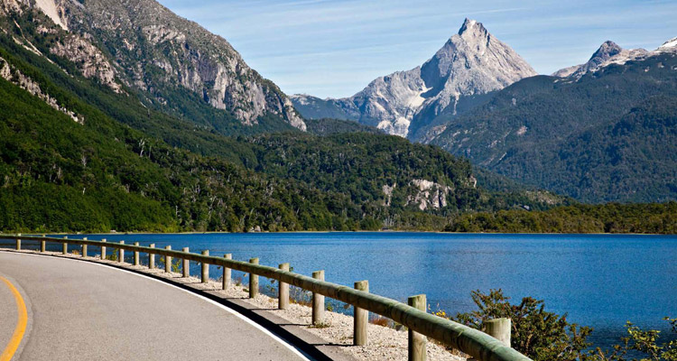
Picture of the Carretera Austral at Pumalin Park/ “Scenic Route”

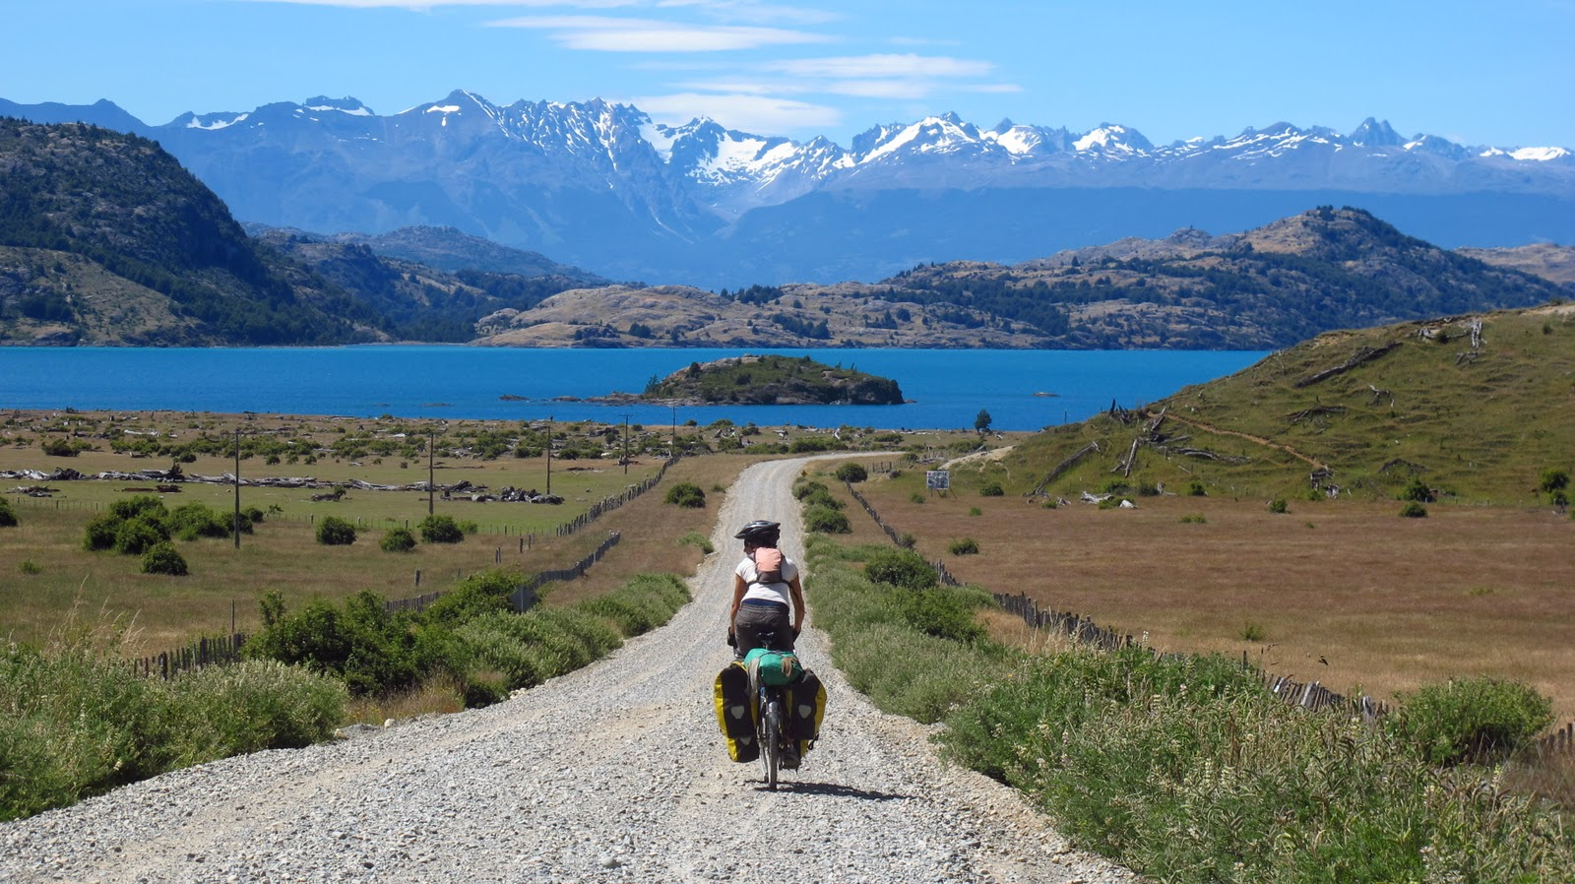
Carretera Austral outside of Pumalin Park

Conclusion

An ancient Cree Indian proverb says: ¨When the last tree is cut, the last river poisoned, and the last fish dead…We will discover we can’t eat money¨ We tend to see human progress and the environment as two separate things when in fact human progress wouldn’t exist without the latter. Adopting sustainable models of living is the only way to sustain our current human progress. This is why conservation models such as Pumalin Park are so crucial for a responsible human progress. My research has proven that it is, in fact, possible for human progress to not only coexist, but thrive alongside the Pumalin conservation model. Each environment faces different threats and is subject to different climatic conditions, so naturally, it is not easy to replicate the Pumalin conservation model in different ecosystems. Pumalin Park serves as an example of a successful conservation model, and can be used as a template for conservation throughout the world. This example, besides acting as a template, encourages the creation of new conservation models that steer human progress in a direction which does not antagonize the environment. Based on my research, I’ve come to the realization that society will never stop caring about the environment, and human development will always occur as long as we exist. This is why we must adopt conservation models such as Pumalin Park, in order to make human progress thrive alongside the environment in a mutualistic manner. If we fail to create a sustainable present, it might be too late to create a sustainable future.

Bibliography

http://www.parquepumalin.cl/en/pumalin_park.htm

https://rainfall.weatherdb.com/l/117/Boston-Massachusetts
ELBROCH, MARK. Revista Chilena De Historia Natural - Long-distance Dispersal of a Male Puma (Puma Concolor Puma) in Patagonia. Revista Chilena De Historia Natural - Long-distance Dispersal of a Male Puma (Puma Concolor Puma) in Patagonia. Revista Chilena De Historia Natural, n.d. Web. 24 Feb. 2016.

http://www.parquepumalin.cl/en/amarillo_beautification.htm

Burke, Ingrid C., William K. Lauenroth, and Debra P. Coffin. “Soil Organic Matter Recovery in Semiarid Grasslands: Implications for the Conservation Reserve Program”. Ecological Applications 5.3 (1995): 793–801. Web...

http://www.conservacionpatagonica.org/whypatagonia.htm

Environmental Earth Sciences, 2012, Volume 66, Number 7, Page 2097
María del Pilar Alvarez, María Marta Trovatto, Mario Alberto Hernández

http://www.parquepumalin.cl/en/scenic_route.htm

Eckersley, Robyn. A paradise called Parque Pumalin: philanthropy or colonialism? [online]. Arena Magazine (Fitzroy, Vic), No. 40, Apr/May 1999: 31-33. Availability:<http://search.informit.com.au/documentSummary;dn=990909316;res=IELAPA> ISSN: 1039-1010. [cited 16 May 16].

LANGHOLZ, JEFFREY A., and JAMES P. LASSOIE. "Perils and Promise of Privately Owned Protected Areas." Bioscience.oxfordjournals.org. N.p., Dec. 2001. Web. 16 May 2016.

https://www.nps.gov/yell/learn/nature/index.htm

https://www.nps.gov/yose/index.htm

http://www.parquepumalin.cl/images/pic_el_amarillo_beautification_06.jpg

Uw-L Journal Of Undergraduate Research Xiii (2010). "Creating Patagonia National Park: Understanding Community Response to National Park Creation by a Private Foreign Non-profit Organization." UW-L Journal of Undergraduate Research XII (n.d.): n. pag. Web. <http://www.uwlax.edu/urc/JUR-online/PDF/2010/bantle.PS-PA.pdf>.

http://www.parquepumalin.cl/images/header_scenic_route.jpg

http://www.parquepumalin.cl/images/pic_el_amarillo_beautification_07.jpg

Tompkins**, Douglas. "IV. THE NEXT ECONOMY. TRANSITIONS FROM GLOBALIZATION TO ECO-LOCALISM*." (n.d.): n. pag. Web. <https://www.researchgate.net/profile/Fabien_Bourlon/publication/263183003_THE_NEXT_ECONOMY._TRANSITIONS_FROM_GLOBALIZATION_TO_ECO-LOCALISM/links/02e7e53a1b07ae3f2b000000.pdf>.

http://www.parquepumalin.cl/images/pic_pumalin_sur05.jpg

http://3.bp.blogspot.com/-1YHT9ujPef8/TxY32tE8bjI/AAAAAAAAAfo/eQtIeyTOTps/s1600/IMG_6617.JPG

Mar, Laura A. "Private Protected Areas and Land Grabbing in Southern Chile." (n.d.): n. pag. Web. <http://dspace.mit.edu/handle/1721.1/53068>.

Marsh, John S. "Parks in Chile: Progress and Problems." (n.d.): n. pag. Web. <http://casiopa.mediamouse.ca/wp-content/uploads/2010/05/PRFO-2003-Proceedings-p295-302-Marsh.pdf>.

